Chocolate Sales Analysis Dashboard (Power BI)

Abstract
This project presents the development of an interactive Power BI dashboard for analyzing chocolate sales across multiple business dimensions, including product performance, geographic distribution, shipment patterns, and profitability. The objective is to convert raw transactional data into meaningful insights through data cleaning, data modeling, DAX measure creation, and interactive visualization. The dashboard incorporates KPIs, year-over-year comparisons, profitability indicators, and performance rankings. The insights generated support improved decision-making and highlight the value of business intelligence tools in analyzing complex datasets.
Executive Summary
The chocolate industry is highly dynamic, requiring continuous monitoring of sales, profit trends, and distribution patterns. This project focuses on constructing a comprehensive business intelligence dashboard using Power BI to evaluate chocolate sales performance. The dataset includes product-level sales, geographic information, salesperson details, and shipment records.
Data cleaning and transformation were performed in Power Query, followed by building a Star Schema model with clearly defined fact and dimension tables. Several analytical measures were created using DAX, enabling dynamic KPI calculation, year-over-year comparisons, and top-N ranking.
The dashboard allows users to explore key insights such as top-selling products, high-performing salespersons, shipment behavior, and region-wise contributions. This project demonstrates practical BI skills and showcases the utility of Power BI in supporting strategic business decisions.

1. Introduction
Data-driven decision-making plays a crucial role in modern organizations. The chocolate retail sector, in particular, must continuously track performance metrics to stay competitive. With large volumes of transactional data, visual analytics becomes essential to interpret trends, identify opportunities, and optimize business operations.
This project uses Power BI to develop an analytical dashboard that transforms chocolate sales data into a meaningful and interactive visual report. Power BI enables seamless integration of data cleaning, modeling, and visualization within a single platform, making it an ideal tool for this analysis.
The dashboard provides key insights into revenue trends, product performance, geographic distribution, shipment patterns, and profitability, thereby assisting stakeholders in making informed business decisions.

2. Problem Statement
Despite having access to raw sales data, many organizations face the following challenges:
- Lack of consolidated visibility into sales, profit, and product performance.
- Difficulty in comparing year-over-year results and identifying long-term trends.
- Inability to quickly identify top-performing or underperforming products and salespersons.
- Limited insights into shipment behavior and operational efficiency.
- Need for an interactive analytical system that supports drill-down analysis.
This project addresses these challenges by designing a structured Power BI dashboard that enables comprehensive exploratory analysis of chocolate sales.

3. Objectives
The primary objectives of this project are:
- To analyze total revenue, profitability, and distribution metrics.
- To compare Current Year (CY) vs Previous Year (PY) performance.
- To identify top-performing products and salespersons.
- To study shipment behavior and operational characteristics.
- To evaluate geographic sales distribution.
- To build an interactive dashboard using Power BI that supports decision-making.

4. Methodology
The methodology followed in this project includes:

4.1 Data Collection
The dataset used in this project is the “Sample Chocolate Shipments Data – Apr 2025” file, which is publicly available through user-shared resources on Scribd. It contains shipment-level chocolate sales data, including fields such as ShipmentID, ProductID, SalespersonID, GeographyID,SalesAmount,BoxesSold,Profit,andShipdate.
Source: Sample Chocolate Shipments Data All Apr 2025 (Scribd).
4.2 Data Cleaning (Power Query)
- Removed null and duplicate records
- Standardized column formats
- Created derived fields where required
- Corrected data types for numeric and date fields
4.3 Data Modeling
A Star Schema was designed to optimize performance:
- Fact Table: Sales
- Dimension Tables: Product, Date, Country, Salesperson
4.4 DAX Calculations
Custom measures created include:
- Total Amount
- Total Profit
- Total Boxes
- Profit %
- YOY Amount
- YOY Boxes
- Ranking metrics (Top Products, Top Salespersons)
4.5 Visualization Design
Dashboard elements include:
- KPI cards
- Bar charts
- Line charts (CY vs PY comparisons)
- Donut charts
- Shipment trend visuals
- Product profitability bars
4.6 Interpretation
Each visual was analyzed to extract trends, patterns, and business insights.

5. Literature Review
Existing literature emphasizes the importance of business intelligence tools in analyzing retail performance. Studies highlight that:
- Data visualization improves comprehension of large datasets.
- Star-schema modeling enables efficient analytical processing.
- DAX calculations provide flexibility in dynamic reporting.
- Power BI has become a widely adopted tool due to its ease of use, scalability, and interactive capabilities.
This project applies these principles in a practical BI environment.

6. Scope of the Project
In Scope
- Sales data analysis
- Profitability evaluation
- Product and salesperson performance ranking
- Geographic analysis
- Shipment behavior pattern analysis
- Dashboard development in Power BI
Out of Scope
- Real-time data connectivity
- Predictive analytics
- Integration with external APIs
- Advanced statistical modeling

7. Limitations
- The analysis depends entirely on the quality and completeness of the provided dataset.
- The dataset represents a limited sample and may not reflect real market complexity.
- Real-time refresh, incremental data load, and streaming data were not implemented.
- Forecasting and predictive models were not included.

8. Results and Discussion
The dashboard provides a rich set of insights:
8.1 Sales and Profitability
- Total sales amount and profit percentage provide a high-level view of performance.
- Profitability varies significantly across product categories.
8.2 Year-over-Year Trends
- CY vs PY comparisons illustrate growth or decline patterns.
- Certain months exhibit peak sales, indicating seasonality.
8.3 Top Performers
- A small group of top-selling products contributes heavily to overall revenue.
- Certain salespersons consistently outperform others.
8.4 Geographic Insights
- Some countries demonstrate strong sales contribution, while others underperform.
8.5 Shipment Patterns
- Shipment frequency distribution helps understand operational efficiency.
- Certain shipment IDs contribute disproportionately to workload.

These insights enable organizations to optimize supply chain logistics, focus on high-performing categories, and improve sales strategies.

9. Conclusion
The Chocolate Sales Analysis Dashboard effectively demonstrates how Power BI can convert raw transactional data into actionable business insights. Through structured data cleaning, modeling, and advanced DAX calculations, the dashboard offers a detailed view of sales performance, profitability, and shipment activity.
The insights gained highlight key revenue drivers, regional strengths, and operational behaviors. This project showcases the value of BI tools in supporting strategic planning and reinforces the importance of data visualization in modern business intelligence solutions.

10. Future Enhancements
Possible enhancements for future development include:
- Implementing forecasting models for sales prediction.
- Adding real-time data refresh using Power BI Gateway.
- Integrating R or Python scripts for advanced analytics.
- Including drill-through pages for deeper analysis.
- Expanding dataset to incorporate customer demographics.
- Deploying the dashboard to Power BI Service for organization-wide accessibility.

11. References

- Sample Chocolate Shipments Data All Apr 2025. Scribd. Available at: https://www.scribd.com/document/868270595/Sample-Chocolate-Shipments-Data-All-Apr-2025?

- Microsoft Power BI Documentation. Available at: https://learn.microsoft.com/power-bi/

- Power Query Documentation. Available at: https://learn.microsoft.com/power-query/

Chocolate Sales Dashboard Output

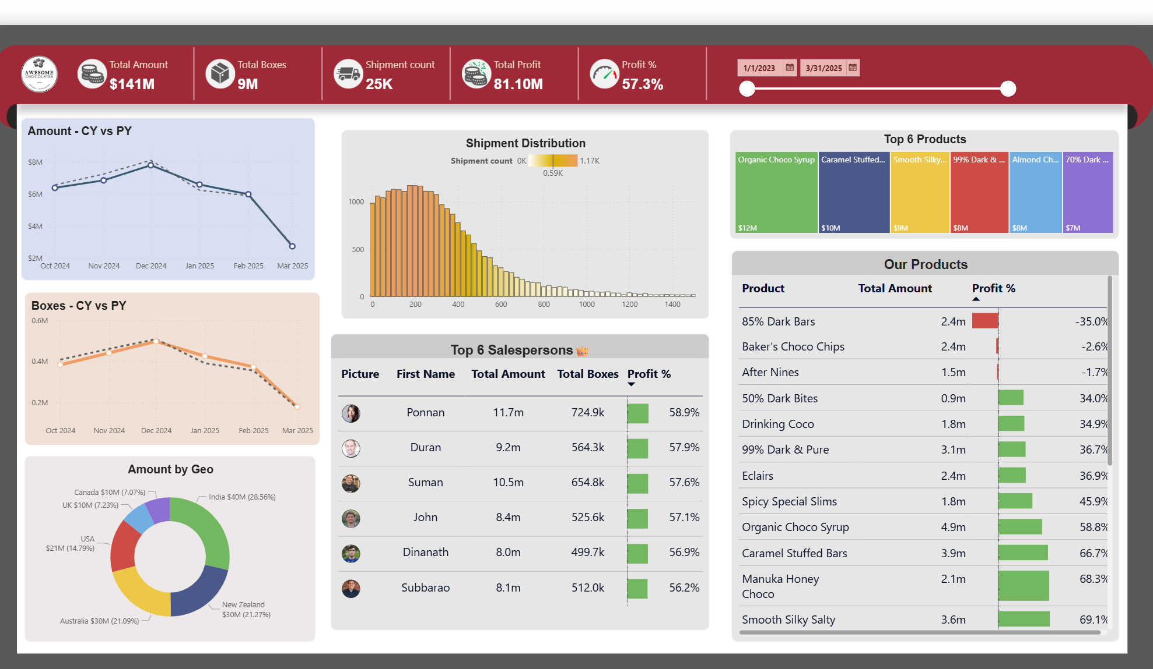
Figure 1: This figure shows the interactive Power BI dashboard used to analyze chocolate sales trends, profitability, and regional performance.

